Answers to questions in

Lab 3: Image segmentation

Name: Alexandra Hotti & Sebastian Ståhl

Program: Cinek-DKOI-MAIG

**Instructions**: Complete the lab according to the instructions in the notes and respond to the questions stated below. Keep the answers short and focus on what is essential. Illustrate with figures only when explicitly requested.

Good luck!

___________________________________________________________________________

**Question 1**: How did you initialize the clustering process and why do you believe this was a good method of doing it?

**Answers:**

We initialize the clustering **by randomly** selecting center values **from the image pixels** color values as our center means.

We believe that this is a good initialization method since it is likely that we will obtain centers that approximately represent the proportion of different colors in the image that are represented in the objects.

Another method could have been to manually set appropriate starting means depending on the image. We could for instance have manually set the starting pixels for the orange as lets say 70% orange pixel variations and 30 % white pixel variations.

**Modifying K**

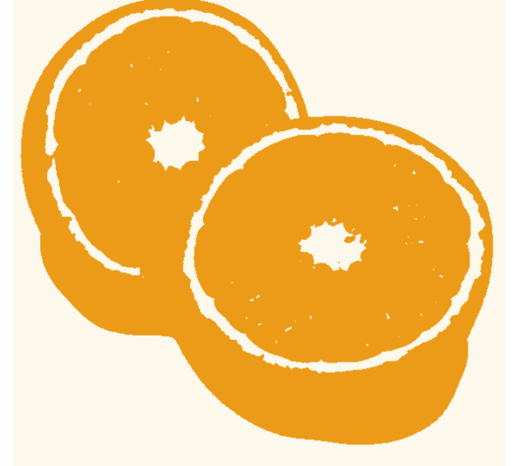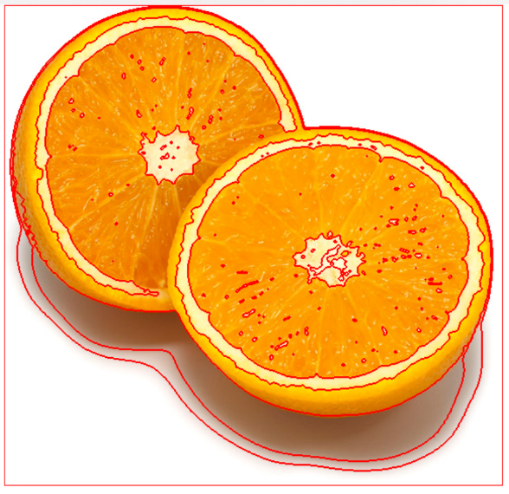

**To few clusters K -> to few colors**

Here we have used K=4, L=10, we can see that the superpixel doesn’t distinguish two different halves of the orange, it sees it as one piece because we have used to few clusters.

**More clusters K-> more colors**

If we increase K, K=8, we get more clusters and we the result is more clear, but the intersection of the borders of the halves are still not fully separated.

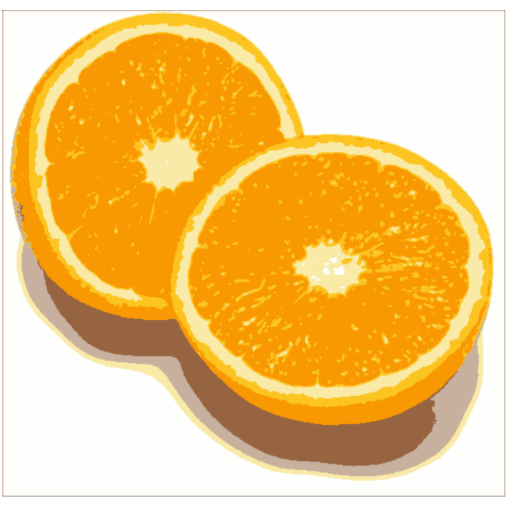 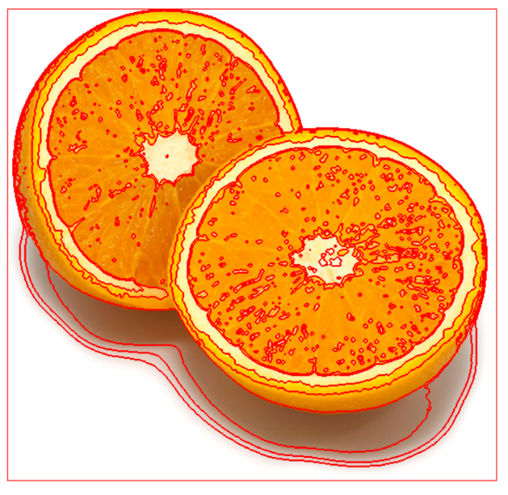

**Modifying L**

**To few iterations -> wrong starting color, L=2**

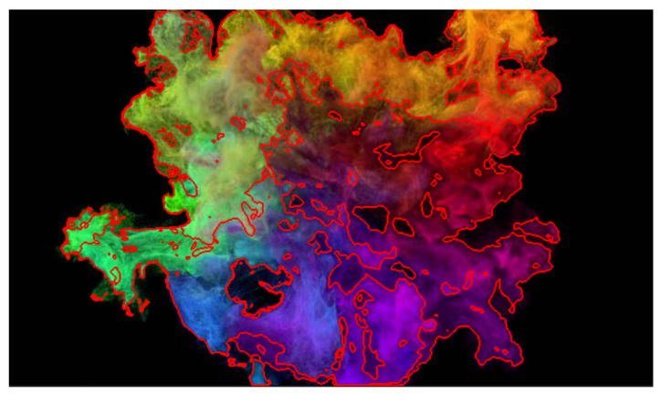 So when we increase the number of iterations we refine the mean of our clusters.

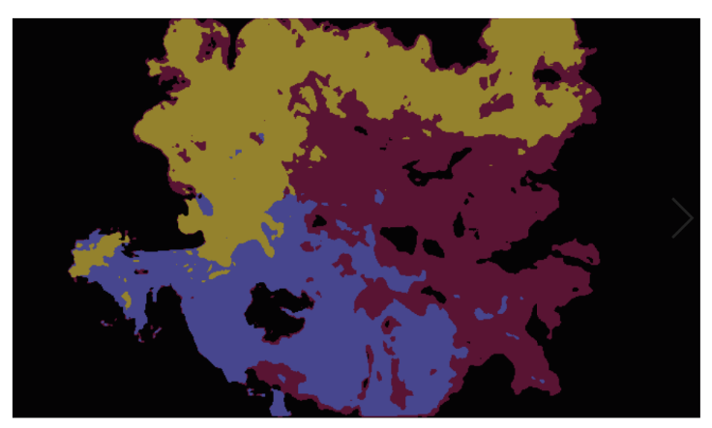In the beginning we randomly ended up with approx 4 colors in the image: yellow, blue, purple and black. The purple and black are already pretty close to the mean of the colors in that region of the image. However looking at the other 2 clusters we randomly generated a blue and a yellow cluster. Therefore the blue/green area that contains both green and blue gets clustered to the blue area. While the green/yellowish area gets clustered to the yellow area.

**More iterations -> refining placement of centers, L=20**

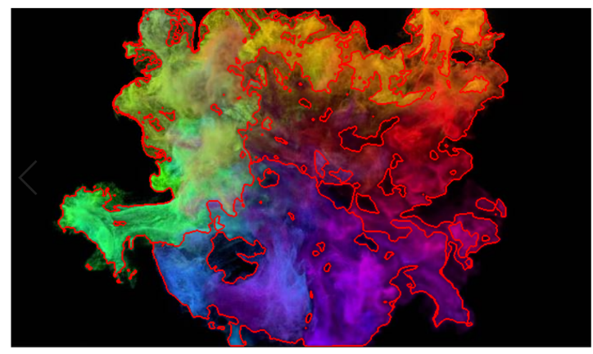

When we iterate eventually at L=20 we have a green, black, blue and purple cluster and all the yellow areas has become part of the green cluster. which makes sense since the mean should be closer to green than yellow since more area in the image is green.

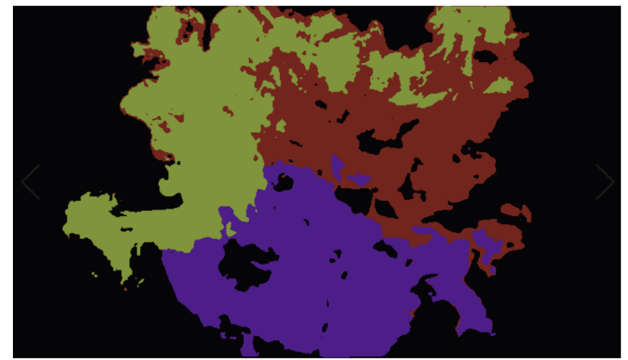

___________________________________________________________________________

**Question 2**: How many iterations L do you typically need to reach convergence, that is the point where no additional iterations will affect the end results?

Answers:

Threshold: 0.01

|  |  |  |  |  |
| --- | --- | --- | --- | --- |
| K | orange | tiger1 | tiger2 | tiger3 |
| 3 | 8 | 13 | 7 | 4 |
| 7 | 18 | 31 | 102 | 109 |
| 9 | 39 | 78 | 140 | 144 |

To ensure convergence we check that the new centers that have moved the most was less then a threshold of 0.01

**Iteration depends on K:** The number of iterations depends on the value for K, when we have more cluster centers the pixels tend to change cluster K more often and therefore convergence takes longer.

**Scale_factor -> We speed up the convergence of kmeans.**

Ex: scale_factor=0.5 half the number of pixels.

This should be better in an image with large objects with not so many small parts sticking out like tiger3 which had thin legs. But if we have larger objects in an image with less details it should work better for instance like the oranges.

**Blurring:** pixelwise. This will **remove coloring distinctions** between parts of the image. Noise for instance. When we **blurr to much the paw becomes part** of the background.( see below)

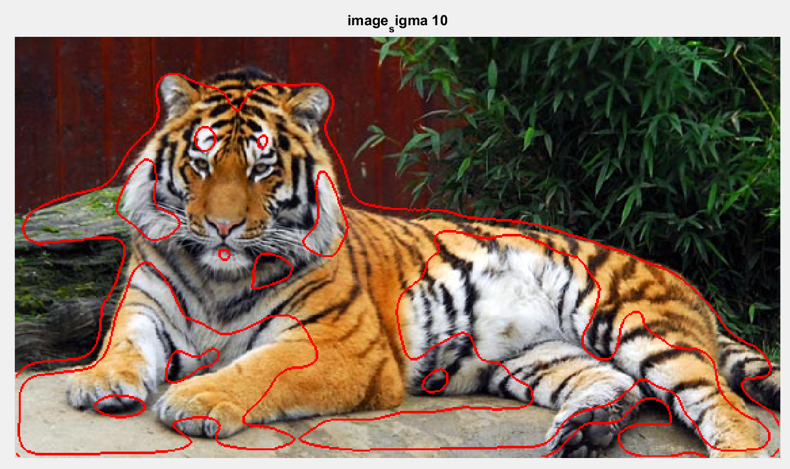

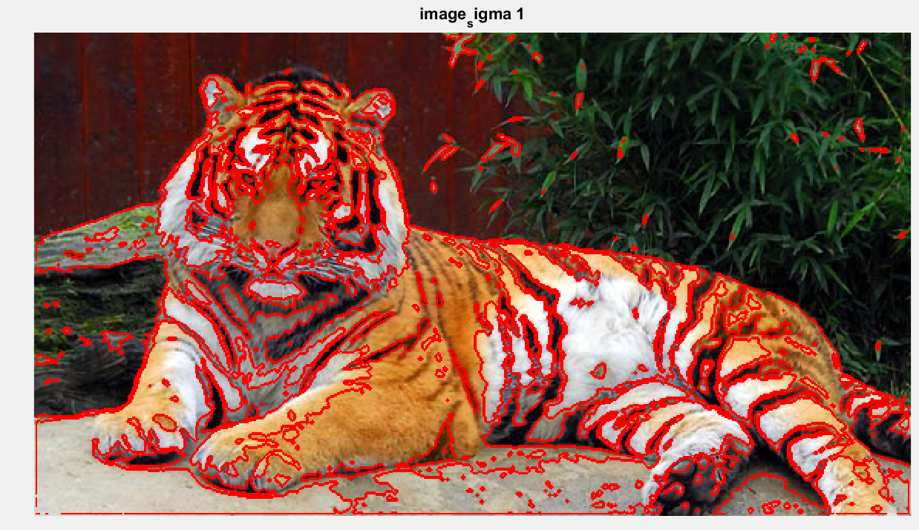

___________________________________________________________________________

**Question 3**: What is the minimum value for K that you can use and still get no superpixel that covers parts from both halves of the orange? Illustrate with a figure.

**Answers:**

Increasing K means that we can represent more colors. So when we have 2 objects with really similar colors, we need many clusters to try to model the small dissimilarities between colors between them.

K=19 (first image) vs K=20 (second image) (L=20)

**K=19**

If we look at the upper corners where the oranges intersect there is a tiny little hole which in the image below clearly results in that the algorithm cannot distinguish between the 2 orange halves.

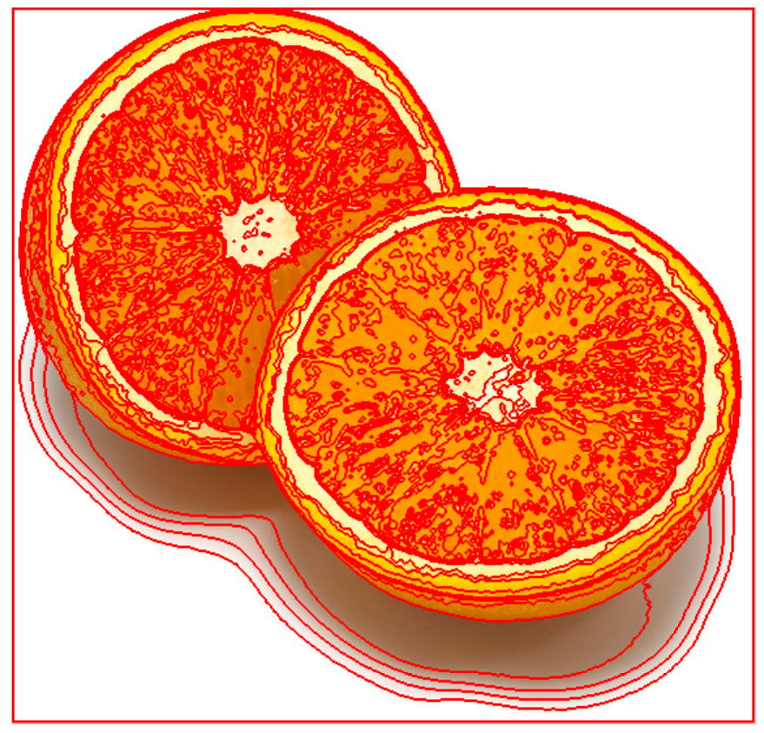

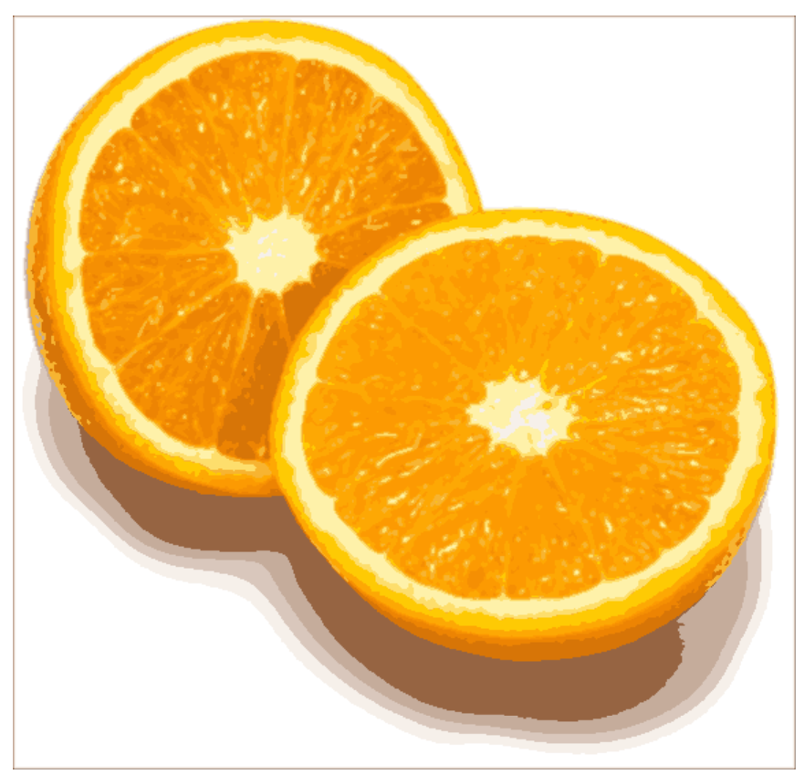

**K=20**

Now if we look at the same point we observe that the little hole is now closed. Which is even clearer in the next picture.

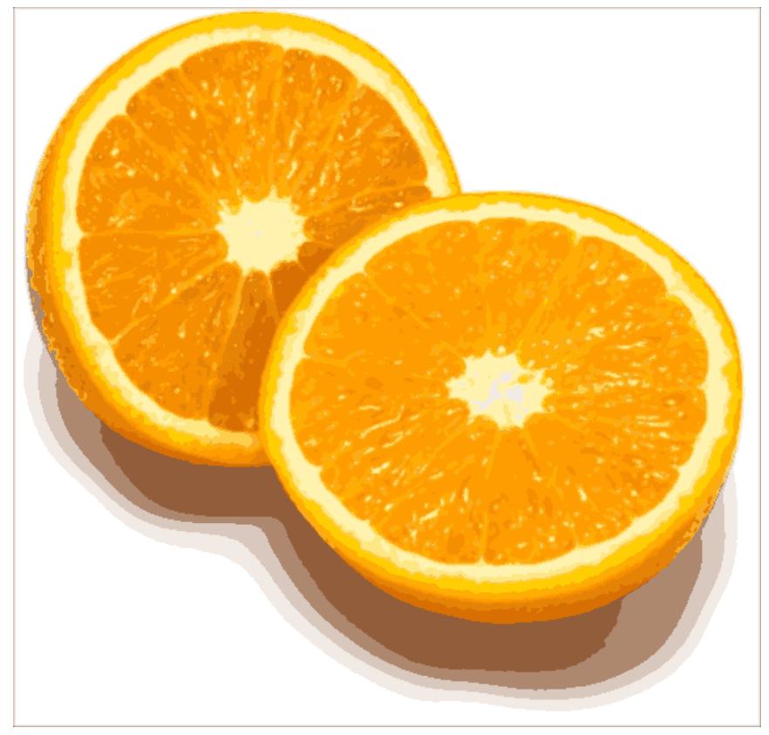

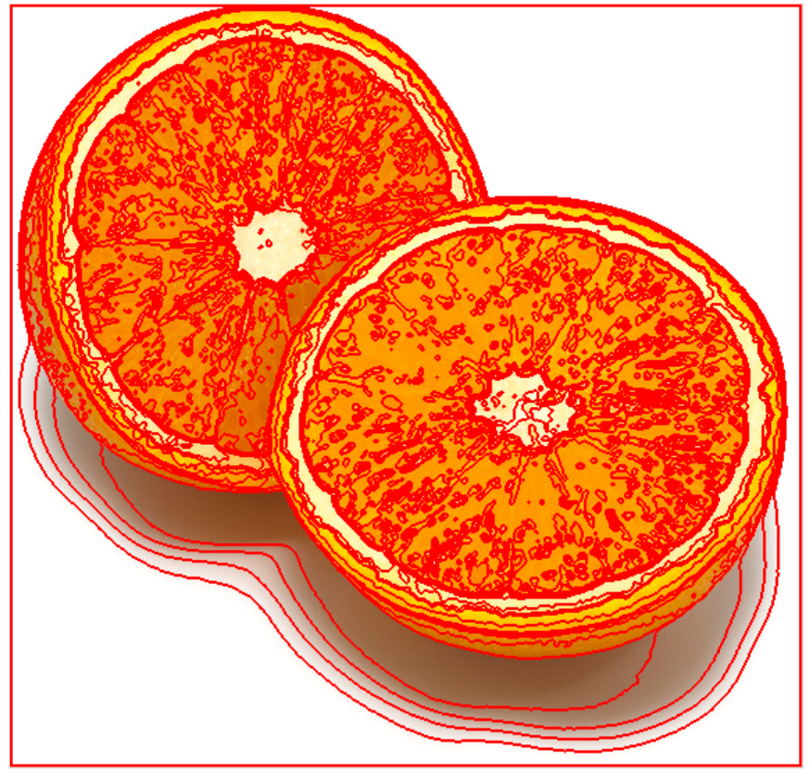

___________________________________________________________________________

**Question 4**: What needs to be changed in the parameters to get suitable superpixels for the tiger images as well?

Answers:

**K=3, L=9 (LESS THAN orange)**

The tiger image needs **lower values for both K and L compared to the orange to get pleasing results for the human eye**. Since it consists of objects of colors that are well separated from each other compared to the orange where the two halves consists of similar colors.

However, we can see that some areas of the tiger still blend in to the surface, such as the top of the front paw.

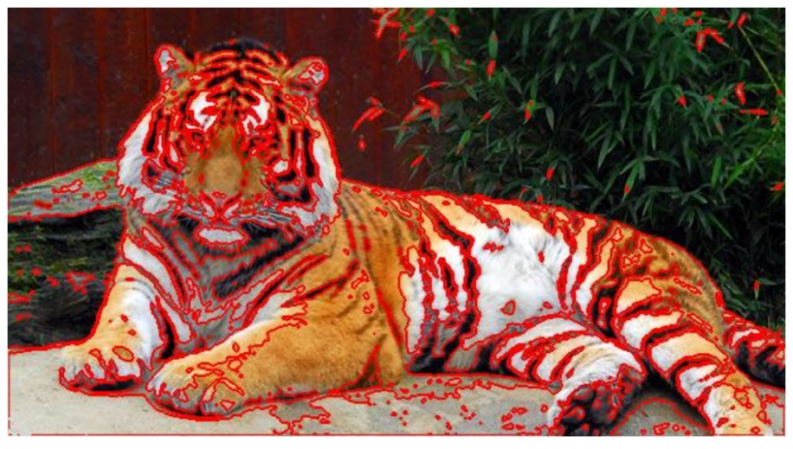

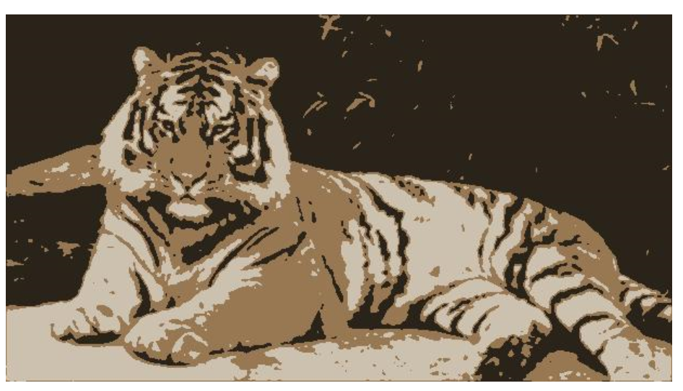

**Tiger2:**

**K=5, L=15 (MORE THAN tiger 1)**

This image consists of a tiger that **blends in more to the background** compared to the other tiger and therefore its **colors are not as easily distinguishable from the background** compared to tiger1. Therefore we need more clusters and more iterations to account for less clear difference between the colors of the tiger and the background.

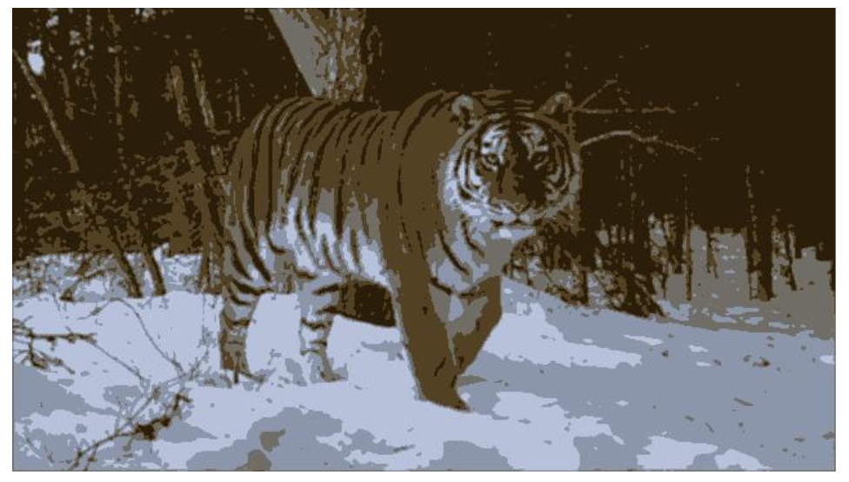

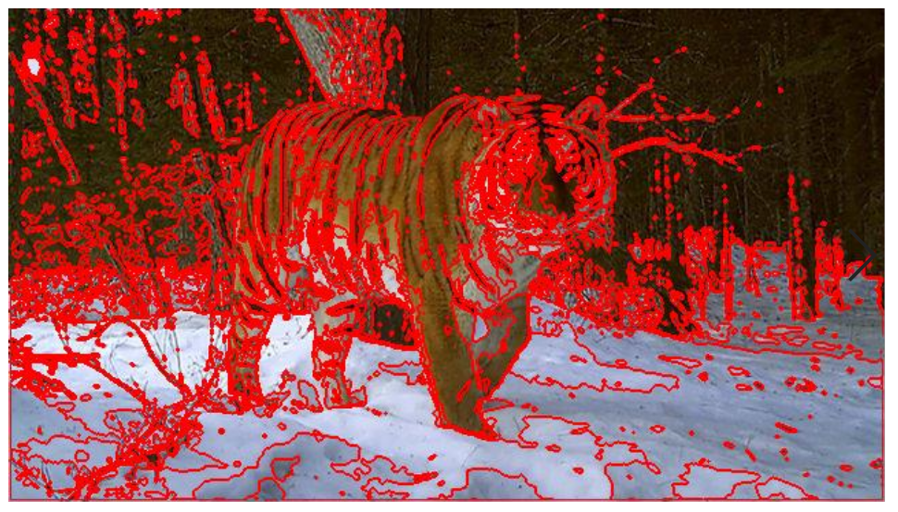

**Tiger 3**

**K=6, threshold =0.01, L=9**

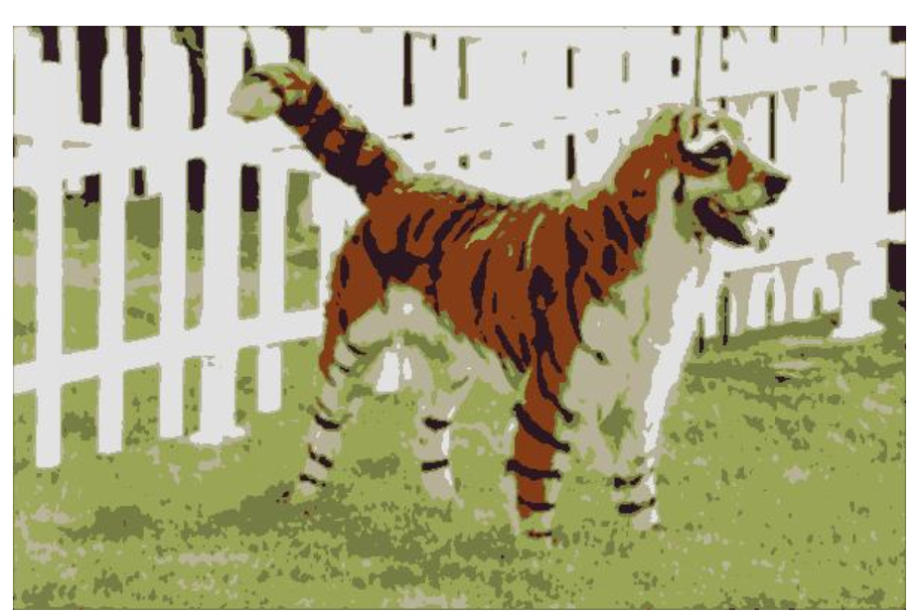

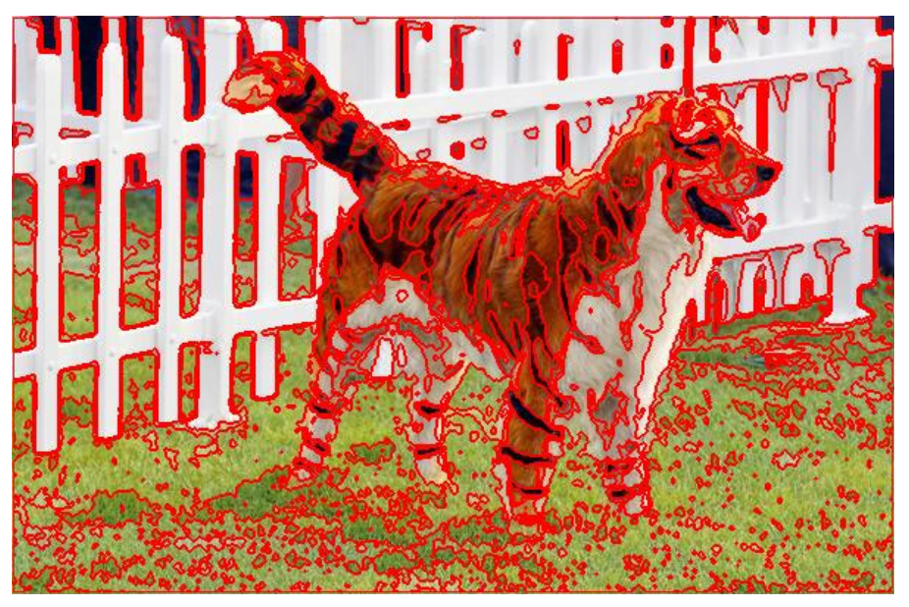

___________________________________________________________________________

**Question 5**: How do the results change depending on the bandwidths? What settings did you prefer for the different images? Illustrate with an example image with the parameter that you think are suitable for that image.

**Answers:**

**Relation spatial vs color variance:** How much importance do we give to color vs location.

**Weights:** So, when we increase the bandwidths we spread out the kernels more. Therefore, we will give less weights to the center pixels and more weight to pixels further away from the center.

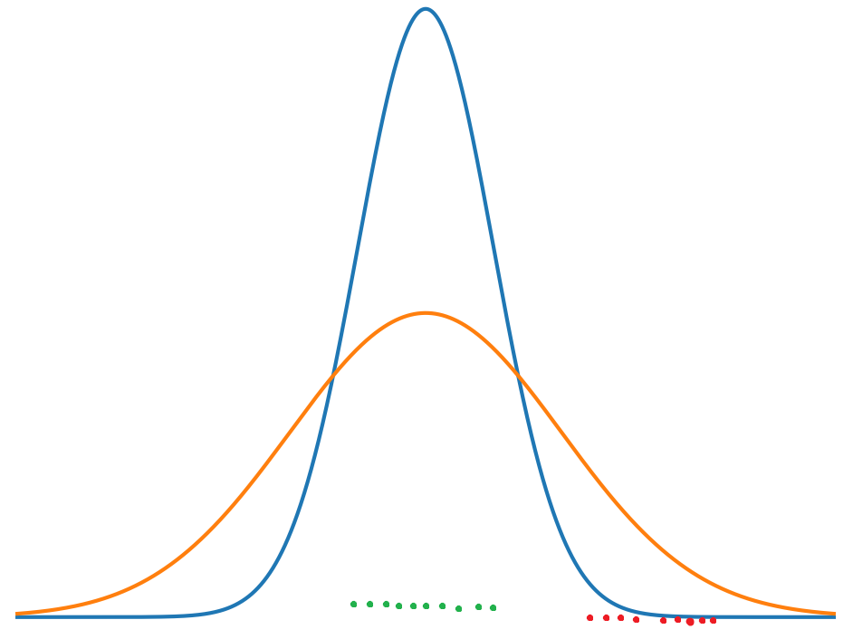

**Number of modes:** Also when we increase the bandwidth we should find less number of modes. Since a smaller bandwidth allows us to find more local maximas/modes. Therefore, using a larger variance becomes more robust against outliers and we get more global regions of interest.

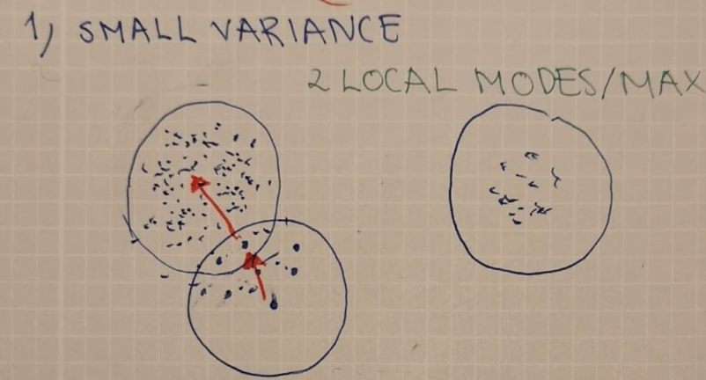

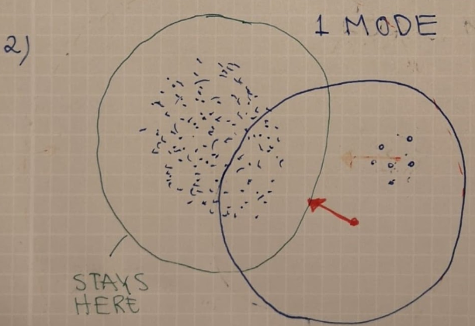

**Color variance:** We **increase the influence of neighboring pixels** color intensities. Therefore in accordance with the image above we will get **less modes** and less color variations in the image and more colors will be segmented to less colors and therefore we will get larger segments in our image.

**Tiger1.jpg - varying the color bandwidth**

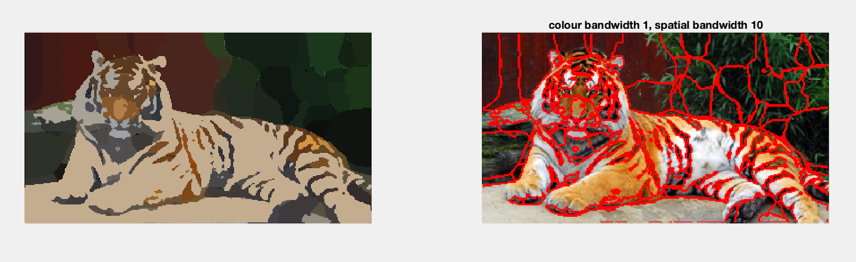

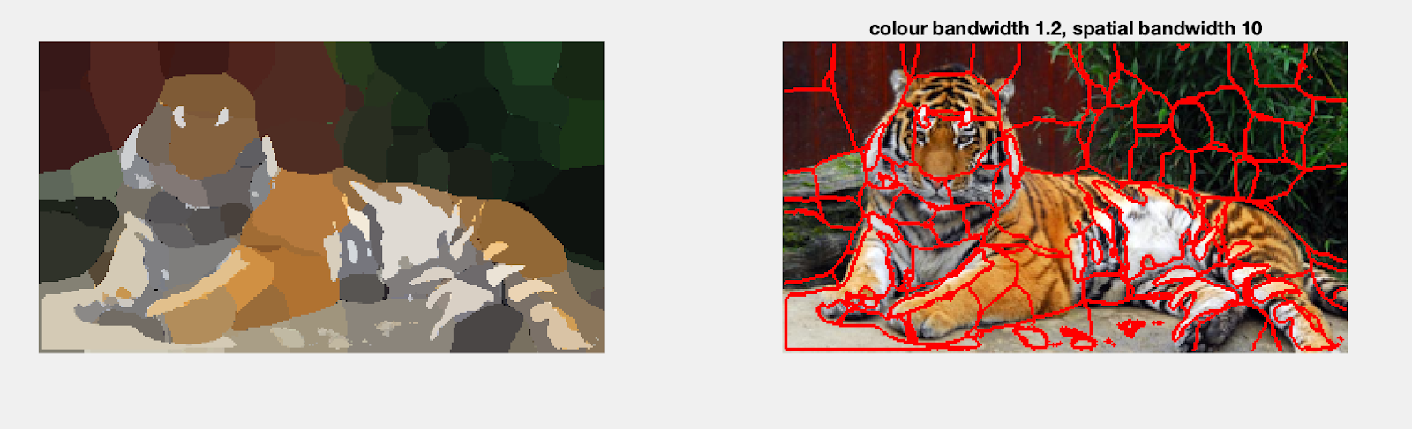

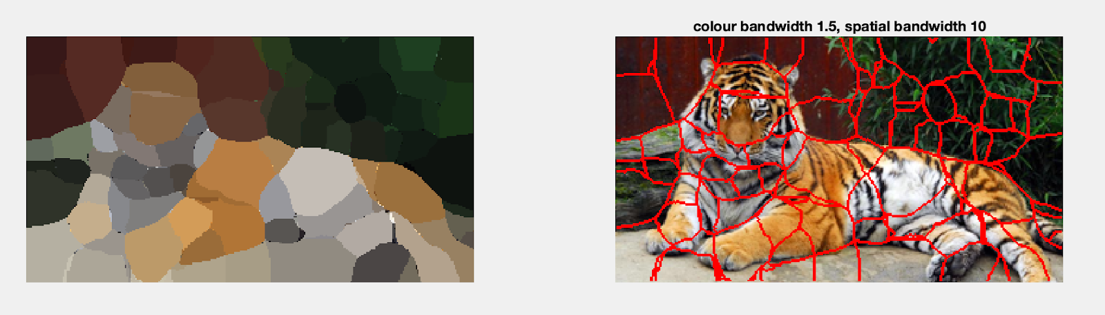

**Spatial Variance:** The same reasoning as above holds also for spatial bandwidth. The **segmenst become larger** and we get **less modes** when we increase the spatial bandwidth.

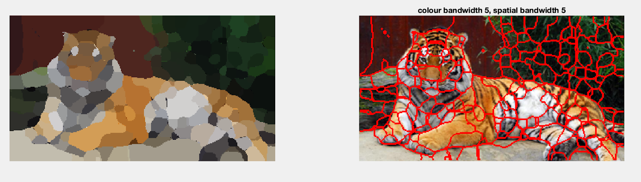

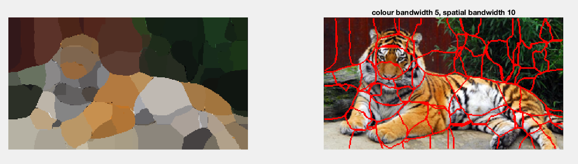

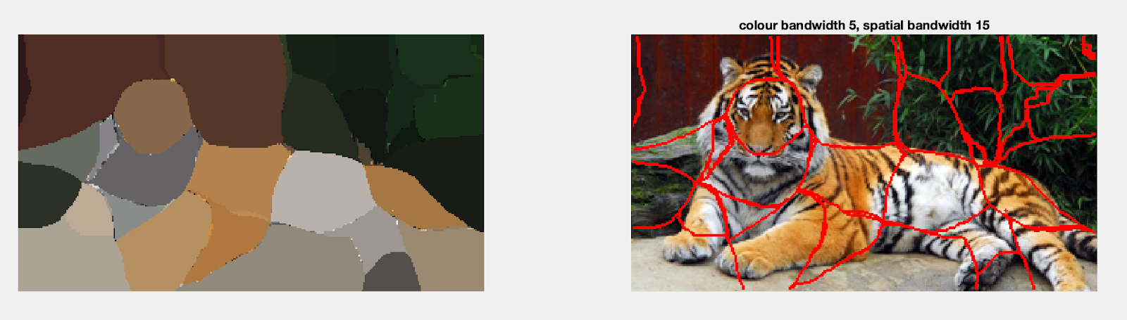

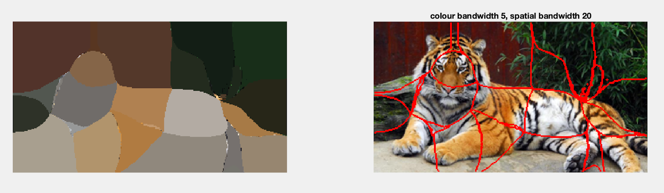

**Image preferences ( tiger vs orange)**

**Tiger – larger difference between colors:** In the tiger the object and the background colors are **well distinguished**. Therefore there is **no risk with removing fine variations** within for instance the orange nuances on the tiger since for instance the background is already well separated from the tiger. Thereby we get better segments within the orange cluster.

**Orange- small variations:** we have really fine differences between colors. If we use a **large color bandwidth all colors will go to the same mode** and therefore, **we cannot distinguish** between the fine color differences in the 2 orange halves.

___________________________________________________________________________

**Question 6**: What kind of similarities and differences do you see between K-means and mean-shift segmentation?

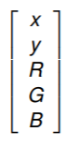Answers:

* **Finding K:** In k-means we manually set the value for K which is difficult, but in Kmeans this is done automatically as we for every pixel/superpixel find modes/regions of high density.
* **Spatial Location:** K-means only takes the color value into account while mean shift also takes location into consideration. Which is good since naturally there are dependencies between neighboring pixels.

EX (mean shift superior): Thus for instance when we want to distinguish to objects with very **similar colors it advantageous** to also take **location into account**. Such as in the case of the orange image.

* **Initialization:** K means is also sensitive to where we place the initial centers since this can result in different solutions. This could also result in clusters where no pixels are assigned to the cluster which could give us zero division.
* **Robustness against outliers:** Mean shift is more robust to outliers compared to k means. Since mean shifts modes end up at the points of **highest density a far away** **outlier** will not affect the result that much compared to **k means which basically takes every points equally into account**. Mean shift – robust outliers pga kernel.
* **Complexity:** in mean shift you find a mode for each pixel. But in kmeans you assign serval pixels at once to a cluster. Therefore kmeans is faster

___________________________________________________________________________

**Question 7**: Does the ideal parameter setting vary depending on the images? If you look at the images, can you see a reason why the ideal settings might differ? Illustrate with an example image with the parameters you prefer for that image.

**Answers:**

Yes, the ideal parameter setting varies a lot depending on the image.

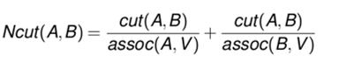

**Orange ( see next page)**

**Radius:** First the orange image contains pretty **large objects** and therefore we need a large radius to account for similarities between opposite edges of the half. For instance ( at p.20) we can see that at first the radius is to small to account for similarities between opposite edges, but as we increase the radius we can do this.

**Max_depth** The image consists of two objects that **stand out** from the background. Therefore, we do not need a deep depth to segment the image. Meaning that **these first cuts already have small values**

**N_cuts_threshold** The cutting threshold should be pretty **low** if we look at the **edges of the orange compared to the white background**. However we need a **higher threshold** to make the **cut in between the two oranges** which have similar colors.

**Min area:** We need a pretty **large min area** since the since of the objects/orange halves are large. If we use to small of a min area we risk segmenting the middle white areas of the orange ( see p. 19)

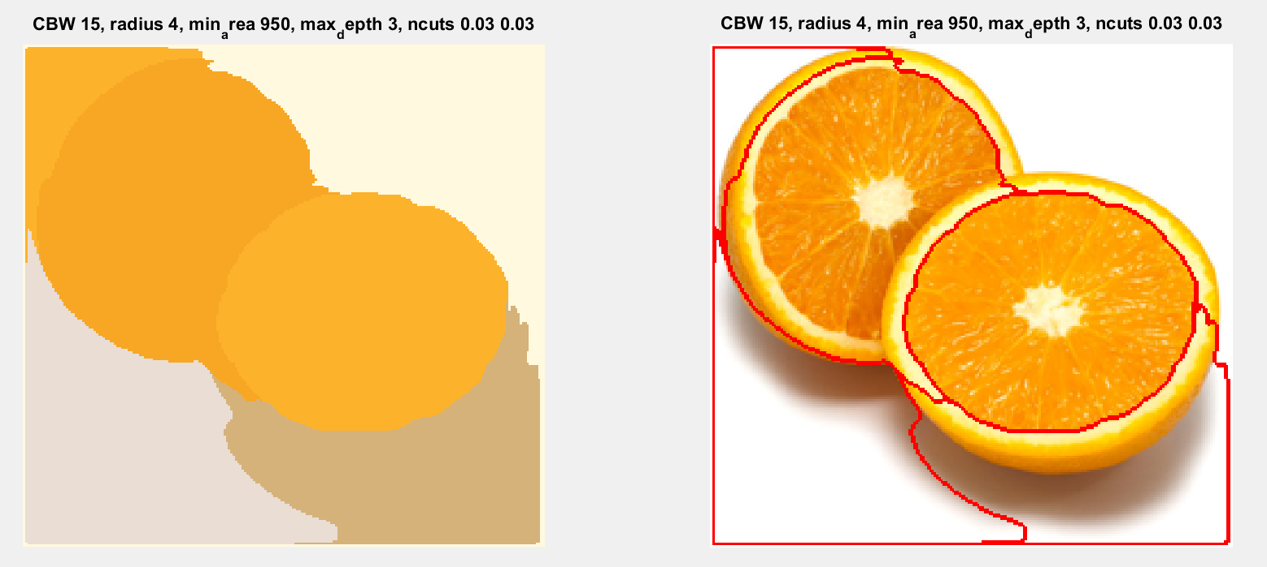

**What does the parameters do**

**Colour bandwidth:** In the code we compute the elements in the **affinity matrix by looking at color similarities between pixels. (**we also weight these by the distance)

**Increasing the colour bandwidth** should thus **increase the spread of the gaussian** around the pixel in the colour domain. Therefore, as we **decrease the peak** of the gaussian we give **less weight to the center pixel and more to surrounding pixels in the colour domain**.

When we decrease the variance we get a gaussain with a really high peak where most of the probability mass is centered right above the pixels own colour. Thus it is almost like we are using the own pixels colour.

**All in all: Increasing variance means that we give surrounding pixel colors more importance, decreasing variance means that we care more about the center pixels own color.**

**Min area** sets the minimum size of a segment. If we want to represent small objects we would like a small min area. However, think about for instance the image of the orange. If we have a really small min area the white part in the middle could perhaps become segmented into a single object. Increasing the min area incorporates it into the orange half instead.

**Orange- min area**

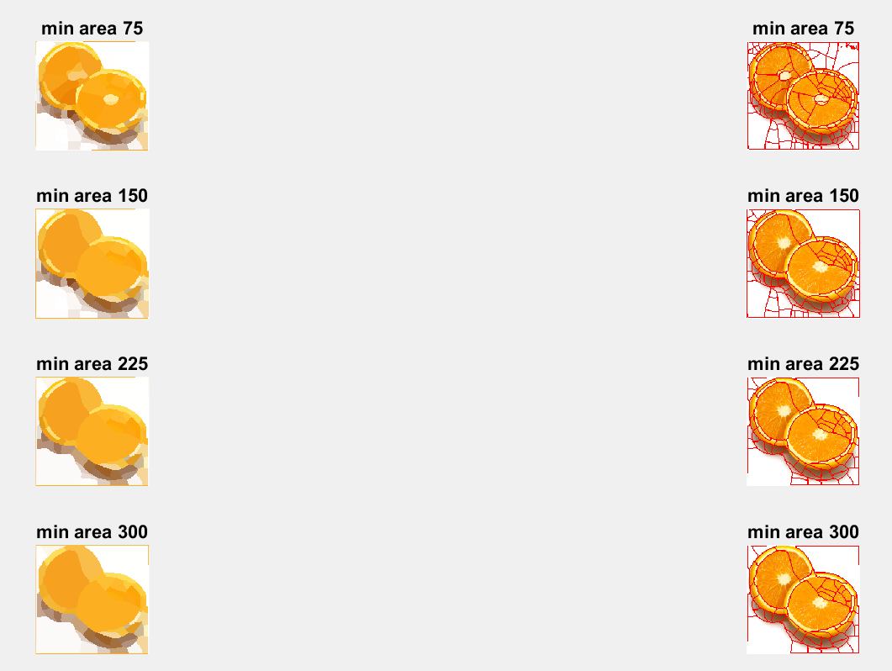

**Tiger- min area**

Smallest possible area for each segment in the image. So here we use min_area=200, and then we increase max depth. We see that after maxdepth=15 the **size of the segments does not decrease.**

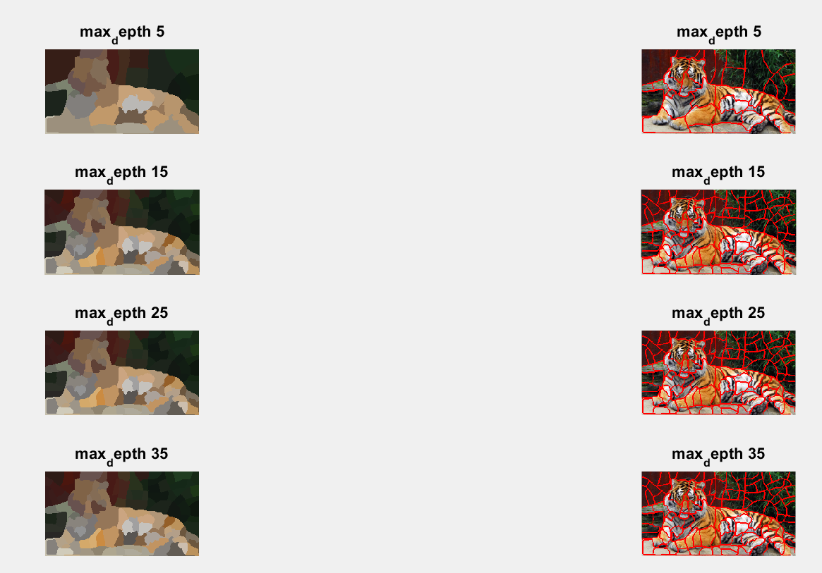

**Radius:** When we decrease the radius, we take less neighbors into account for each pixel when we compute the affinity matrix, therefore we cannot find similarities between pixels that are far away from each other. For instance in the orange image we have large objects and therefore the small radius of 1 cannot account for similarities between pixels at opposite ends of the orange half.

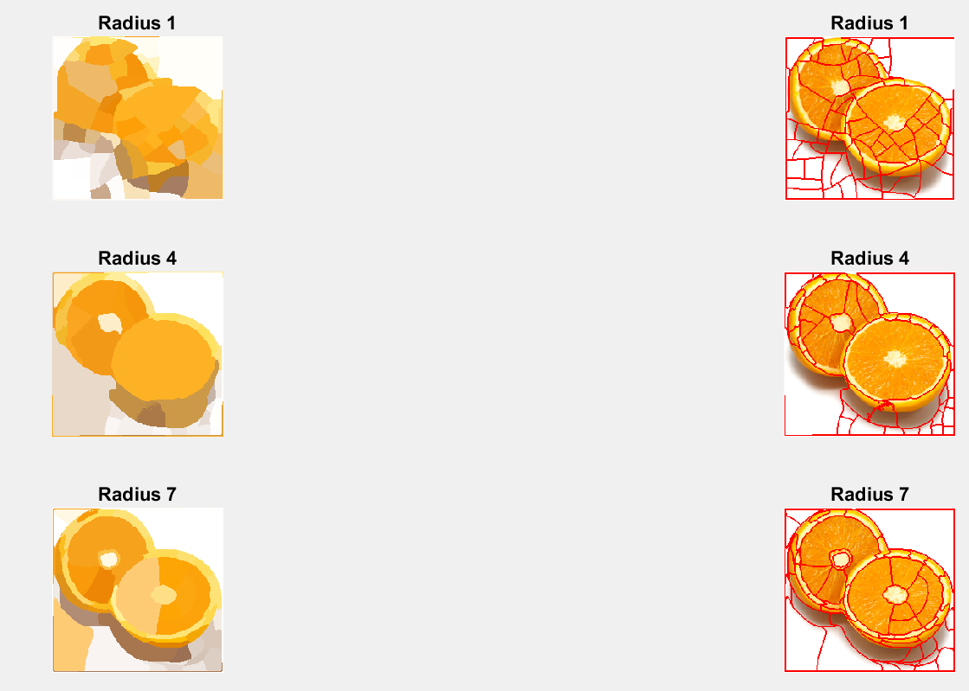

**Max_depth:** Tells us the maximum number of cuts that we can do in the graph.

**Depth 1**.Here first with depth 1 the most obvious cut should be the one between the tiger and the upper background part. The tigers head is darker than its body and spatially it is closely located to the red background, which could explain why it is chopped off.

**Depth 2.** Next above the tigers head we see that the cut is made such that the wall becomes separated from the stone and the green plant which have more similarities in color compared to the red wall.

**Depth 3.** Here we can for instance see that we separate the tigers head from the read wall.

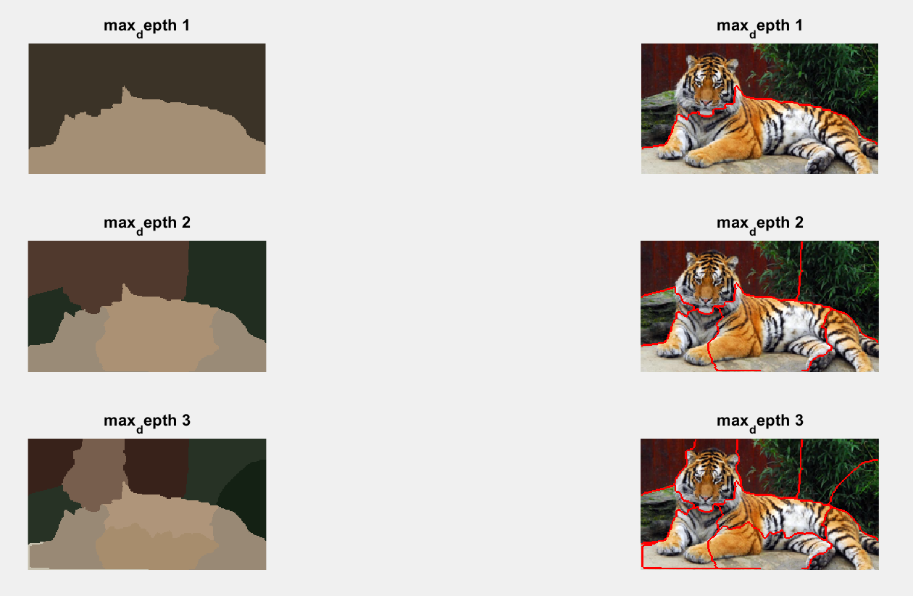

**Ncuts_thresh:** if Ncuts(A,B) >threshold we do not make a cut. Therefore we stop when we do not find small enough cuts anymore.

EX: Here in the tiger image we only make 1 cut when ncuts is equal to 0.01. Which seems like the most obvious boundary to the human eye and therefore this ncut gets a really low value. As we increase the threshold we make less obvious cuts, like for instance sevral cuts through the red wall in the image.

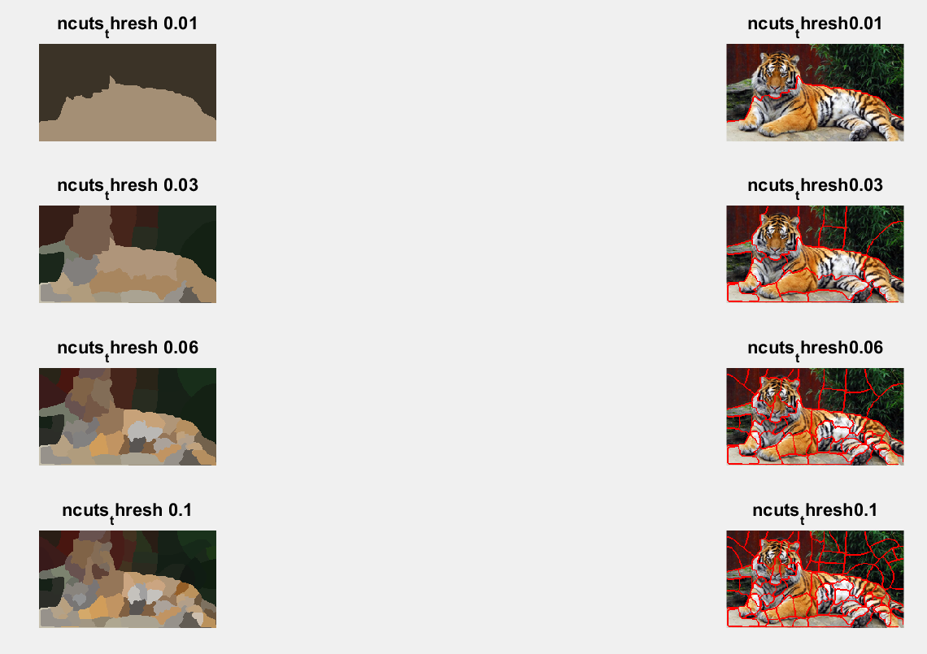

___________________________________________________________________________

**Question 8**: **Which parameter(s) was most effective for reducing the subdivision and still result in a satisfactory segmentation?**

**Answers:** The number of segments are effected by min_area, n_cuts_thresh and max_depth.

How to avoid to many segments depend allot on the image.

Overall: Setting a good min_area for the image at hand and not setting n_cuts to high was important.

**Min_area:** How much we can reduce min area and still get satisfactory segmentation depend on how large the objects in our image is. **Larger objects requires lager min area** (like the orange.)

However, even if the tiger is pretty large we cannot get one large min area segment to fit it. Instead as it has **multiple colors with complex** shapes it seems better to segment smaller areas that we later merge based on neighboring region similarities.

**N_cuts_thresh:** A low n_cuts_thresh is good if we only want to make really low cost cuts in the graph. Therefore if we **decrease n_cuts_thresh** we can be **more certain that we are making good cuts.** However like in the case of the two orange halves, when we have **two objects that are close both spatially and colorwise we want to be able to make higher cost cuts to.** Which could results in **unwanted cuts at for instance the middle of one orange** half.

**Max_depth:** In the case of the orange using a high max depth could result in over segmentation in the image below. Instead it is better to use a lower max depth here. This depth is clearly enough to separate the two halves. However if we look at the next image of the tiger, if we use only a max depth of three the object has not become well separated from the background.





___________________________________________________________________________

**Question 9**: Why does Normalized Cut prefer cuts of approximately equal size? Does this happen in practice?

**Answers:**

First assoc(V)= assoc(A,V)+assoc(V,B)-cut(A,B)

Since both A and B contain the edges that we cut away we need to subtract the cut. We rewrite this below.

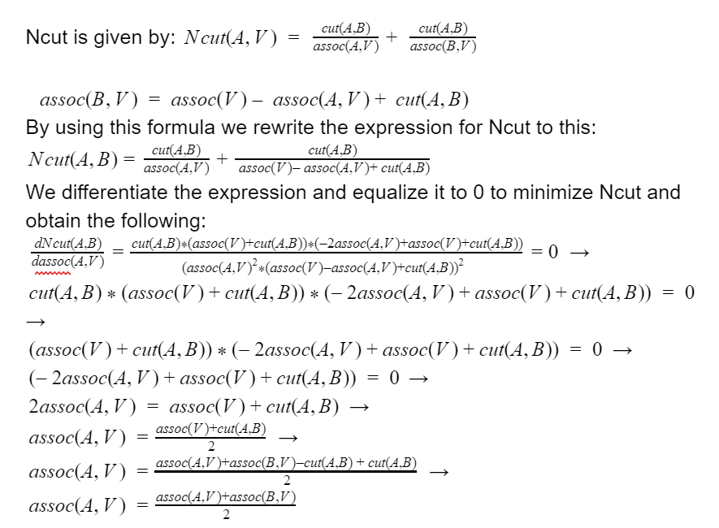

So here we can see the effect of getting approx. 2 equally sized cuts:



___________________________________________________________________________

**Question 10**: Did you manage to increase *radius* and how did it affect the results?

Answers:

It depends on the size of objects in the image. Large objects requires a larger radius to find similarities between far away pixels.

**Radius:** When we decrease the radius, we take less neighbors into account for each pixel when we compute the affinity matrix, therefore we cannot find similarities between pixels that are far away from each other. For instance in the orange image we have large objects and therefore the small radius of 1 cannot account for similarities between pixels at opposite ends of the orange half.



___________________________________________________________________________

**Question 11**: Does the ideal choice of *alpha* and *sigma* vary a lot between different images? Illustrate with an example image with the parameters you prefer.

**Answers:**

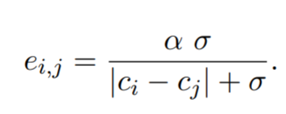

**Alpha:** alpha gives us the maximum edge cost for neighboring pixels. Since when ci = cj eij=alpha. Therefore when we increase alpha we say that we wanna give more weight to neighbor pixels with similar colors. To make less cuts between these.

Below in the tiger image for instance when we increase alpha more of the grey area around the tigers foot become part of the image foreground. Since we increase alpha we are giving neighboring coloring more importance in the graph and these costs becomes costly.

**Sigma:** How edge cost decays for decreasing similarity between pixels.

Meaning that when we increase sigma the relative impact of similar colors becomes higher compared to the relative impact of dissimilar colors. We get a wider scale.

Therefore a low sigma is good when we have really clear edges like at the top of the tiger.

Example (alpha=8)

|  |  |  |  |
| --- | --- | --- | --- |
| **Sigma** | **Similar abs(ci-cj)= 50** | **Dis-similar abs(ci-cj)= 255** | **Diff/decay with decreasing similarity** |
| **10** | 8*10/(50+10)=1.333 | 8*10/(255+10)=0.3 | 1.03 |
| **20** | 8*20/(50+20)=2.28.. | 8*20/(255+20)=0.58 | 1.7 |

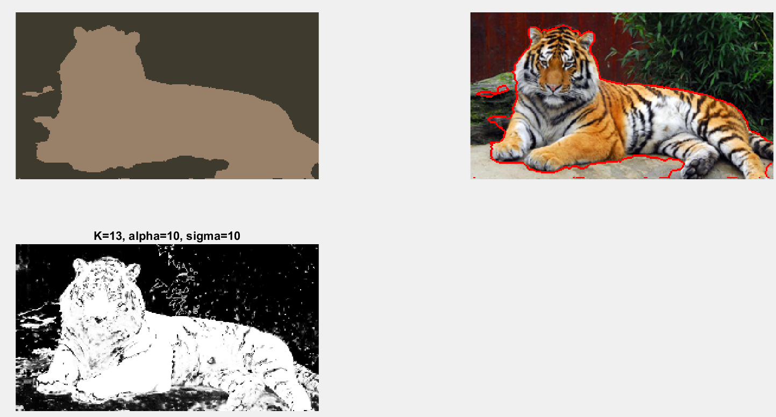

___________________________________________________________________________

**Question 12**: How much can you lower K until the results get considerably worse?

Answers:

More colors -> you need more clusters K to represent the colors in the image.

When we have more colors in an image we need more gaussians.

EX: first we use K=6 and the K=5 for tiger3

When we lower K below 6 we get considerably worse results for tiger3. Which probably is due to the fact that we can no longer model all of the colors within the background and the foreground with so few clusters. Therefore for instance the white leg of the tiger/dog probably becomes more similar to the fence(i.e. background gaussians) then the models used to model the dogs colors.

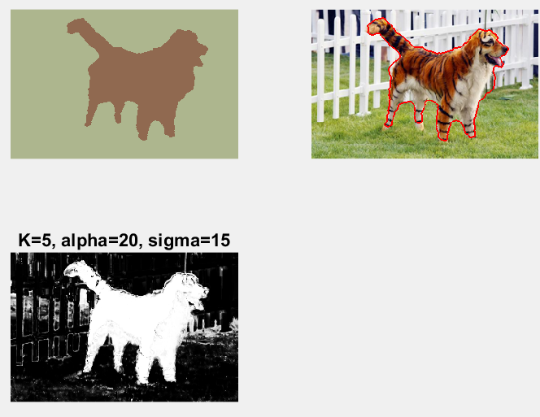

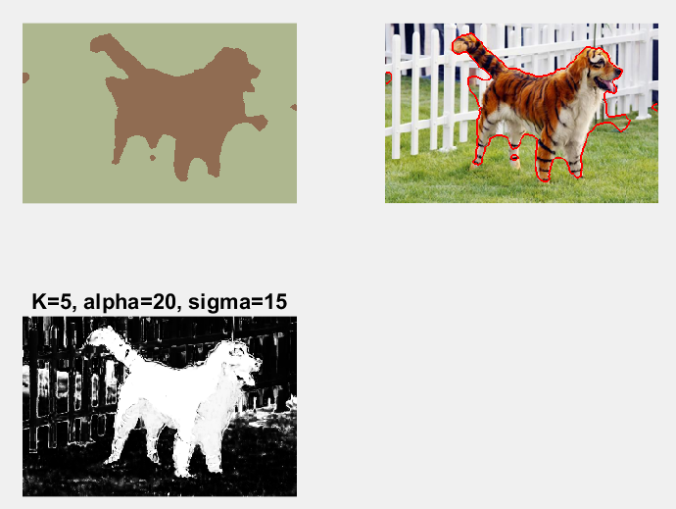

___________________________________________________________________________

**Question 13**: Unlike the earlier method Graph Cut segmentation relies on some input from a user for defining a rectangle. Is the benefit you get of this worth the effort? Motivate!

Answers:

It depends.

**Accuracy:** This method clearly gives us a lot better accuracy then all of the previous models. But, annotating images by placing these rectangles would take a lot of work if it was done manually. Therefore it depends on the accuracy that we would like in our segmentation.

**Object shape:** Lets say that we want to segment a picture of a object which results in a rectangle where most of the inside of the rectangle contains background pixels, but these background pixels are dissimilar to the rest of the background. Then moste of the gaussians modeling the foreground will not model the object that we are looking for.

___________________________________________________________________________

**Question 14**: What are the key differences and similarities between the segmentation methods (K-means, Mean-shift, Normalized Cut and energy-based segmentation with Graph Cuts) in this lab? Think carefully!!

Answers:

All methods look at similarities between color and group pixels that are similar in color.

In **K-means** the user specifics the number **of clusters** to be used in advance, thus it is parametric. Also we do **not take location** into account and therefore its segmentation can result in areas that are not spatially connected.

**In Mean shift** we do not need to specify the number of **modes** to use. We also take the location into account as opposed to k-means.

In our implementation of **Graph Cut** we also specify the number of **gaussians K** to be used to model the colors in the background and the foreground of the image.

Both **Normalized Cut** and **Graph Cut** build **graphs based** on pixel similarities.

Both **mean shift** and **k-means** **cluster pixels** to mean centers and centers of maximum density.

**Mean shift** becomes s**lower** than **K-means** since K-means is **parametri**c and Means shift is not. Which means that we try to **fit all the pixels to the model at once** I k-means but in mean shift we instead **cluster one pixel at the time**

**Graph Cut** requires some **prio**r information regarding which pixels belongs to the foreground and which belongs to the background.

**Normalized Cut** also tries to segment clusters into **equally large segments**, which the other algorithms do no.

___________________________________________________________________________